1. Menu

Need to change like below or like <http://www.lse.ac.uk> .

Every column will be separate menu subject.

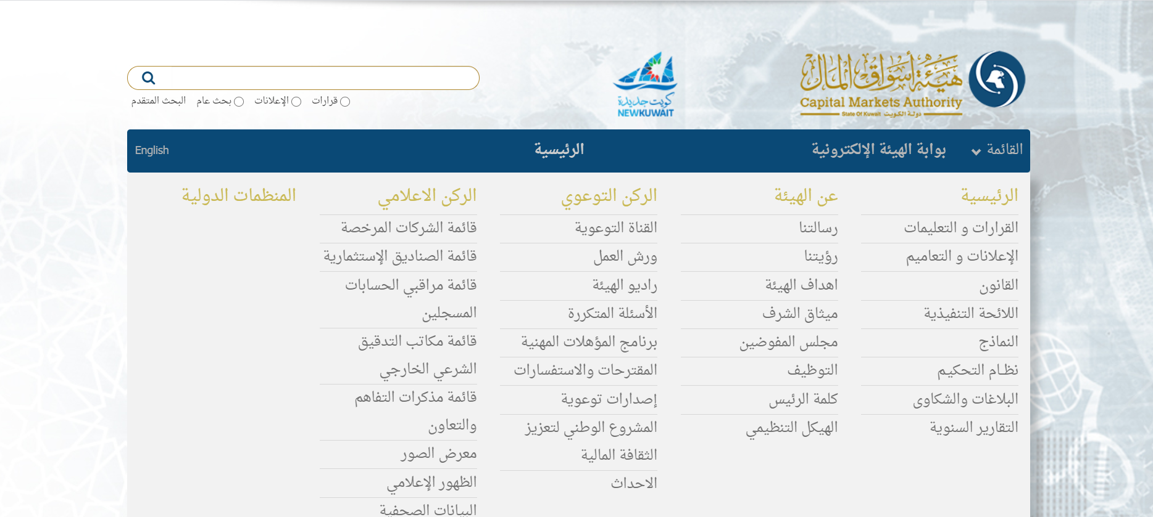

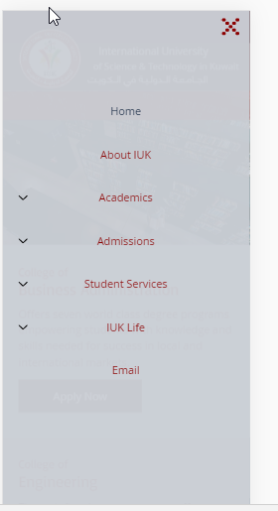

**Feedback:**

**Mouse over with red color on red background will effect visibility**

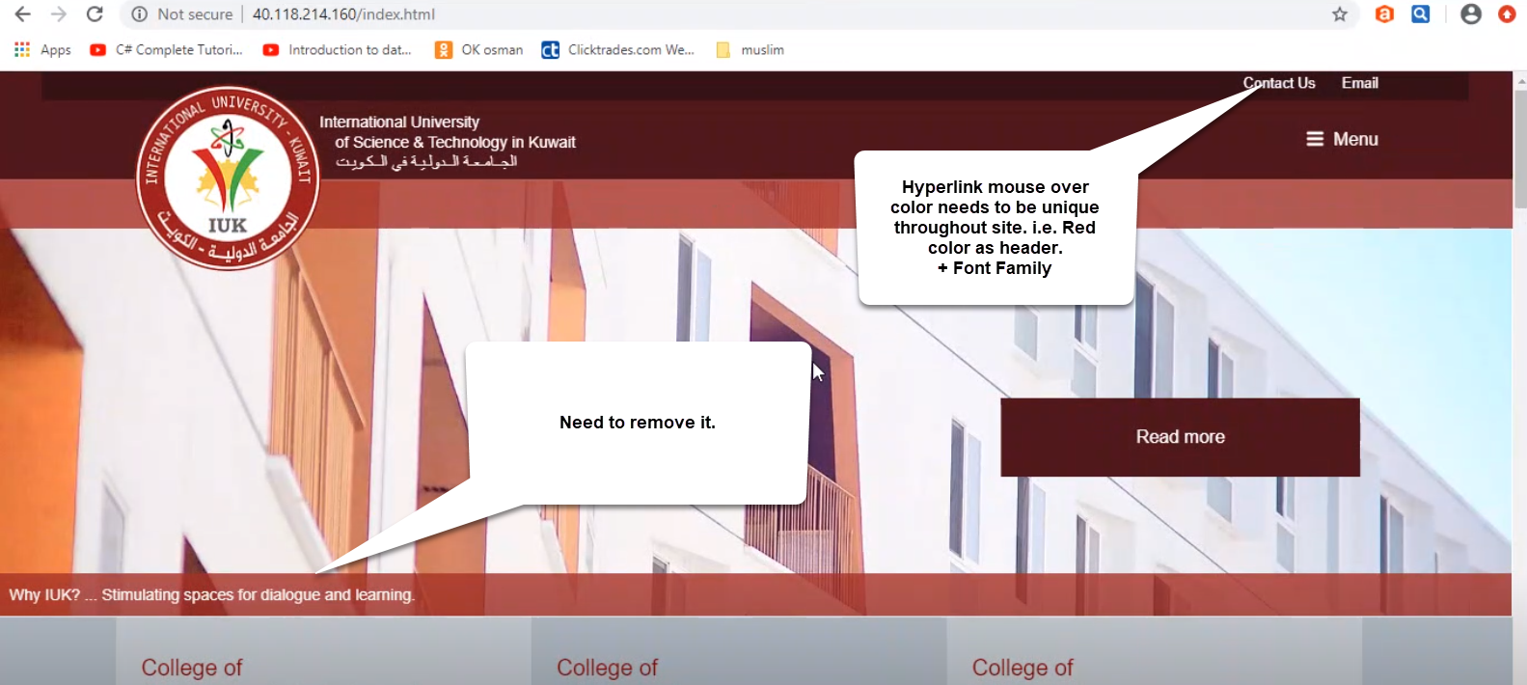

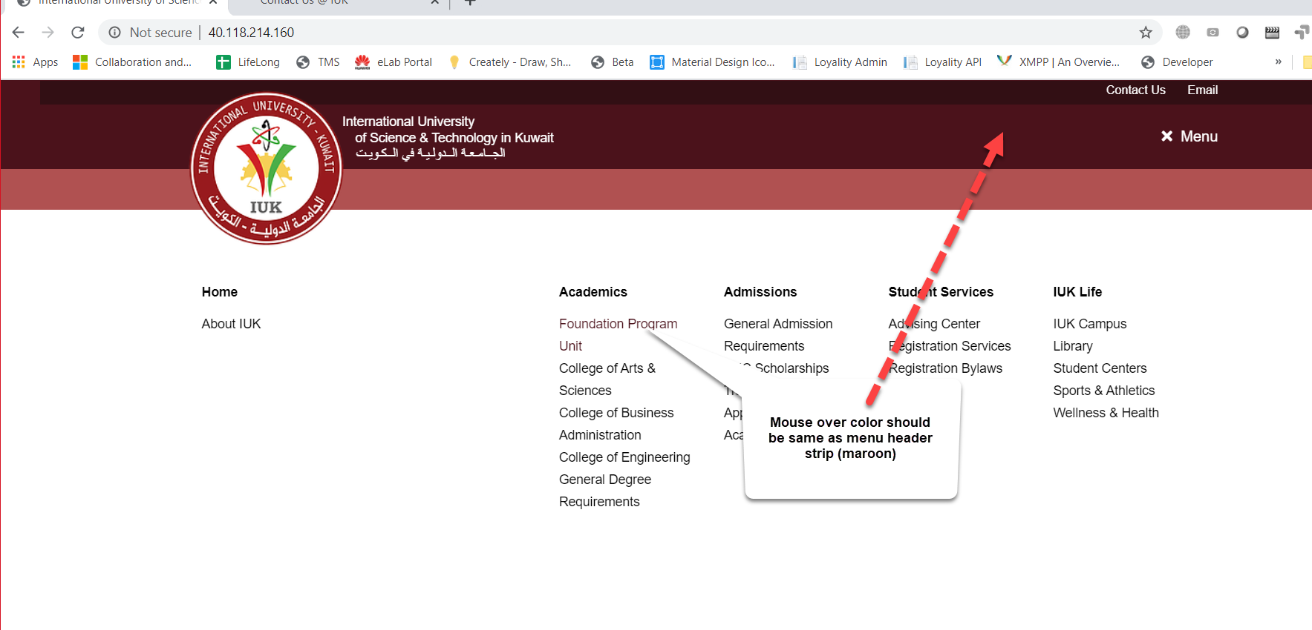

1. Banner area

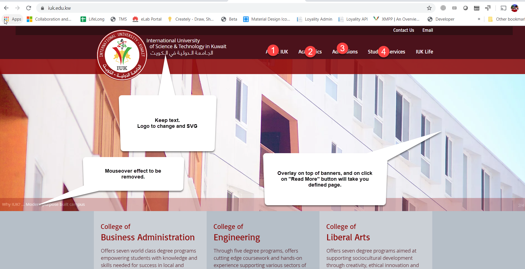

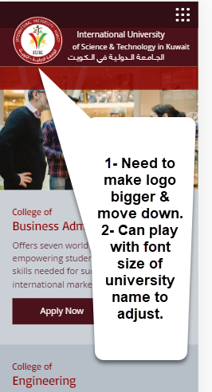

1. 3rd strip.

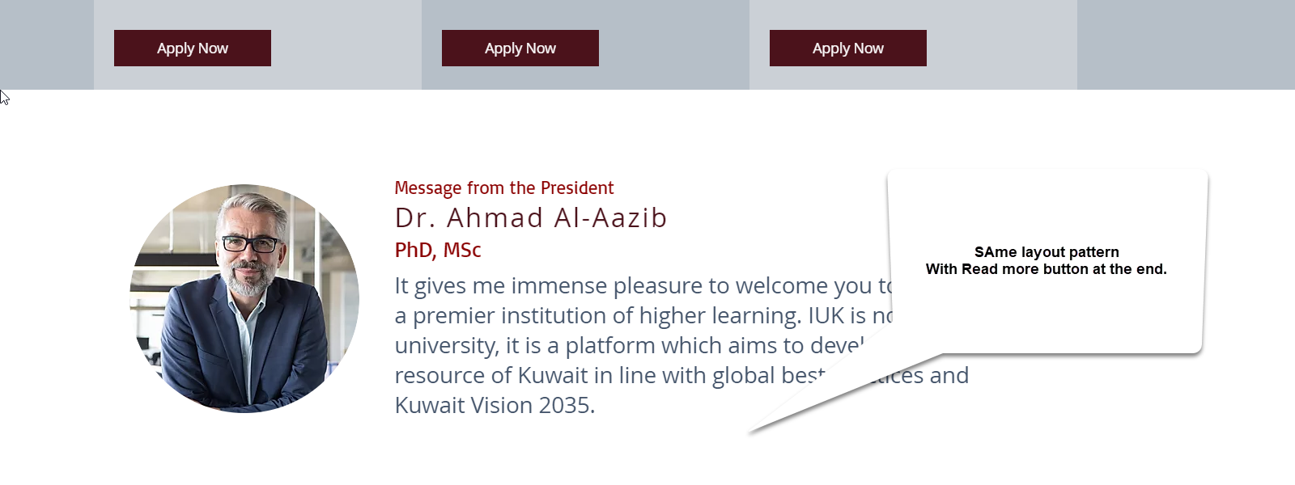

Need to keep same font family. ok

**Feedback:**

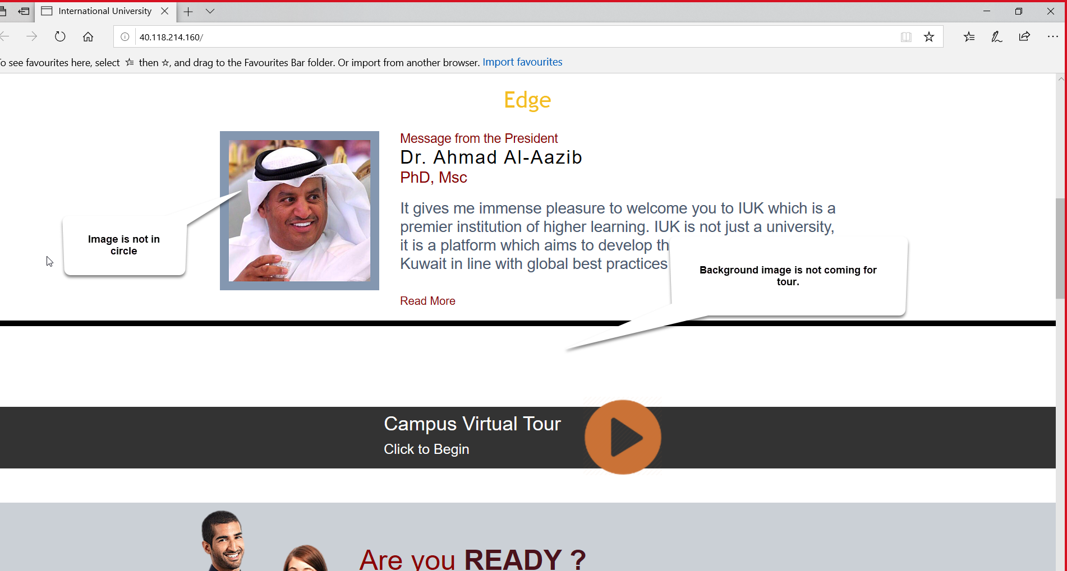

**If image circular is issue, then keep it square even on chrome as well. ok**

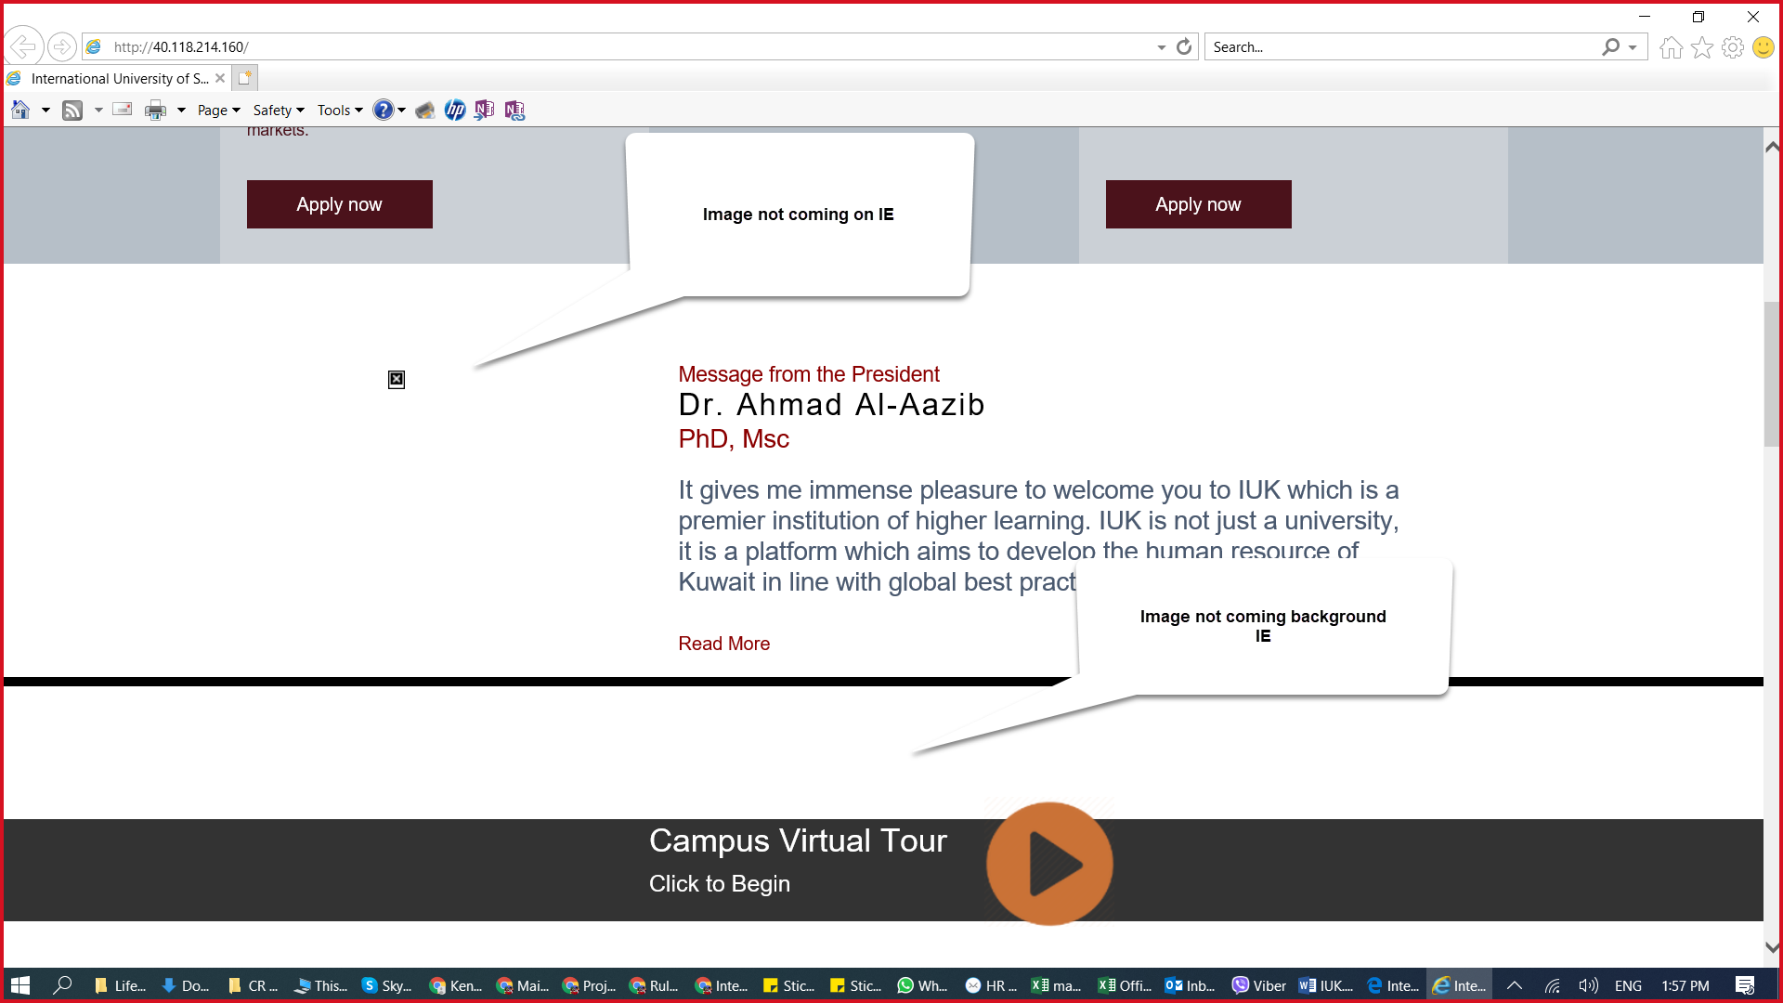

1. Campus tour strip will remain as is. It would be link with another page to display content.
2. Banner strip



1. Banner layout will remain same i.e. Picture, Text, button to action.
2. No. of banner could be 1 or more i.e. there could be two rows of banners with different content.
3. With option to change image and text alignment or keep only text. Like below:



Responsive layout of banners will follow consistent layout arrangement of image, text and button. Please highlight issue here



1. Highlights strip. These feature will be done using backend cant be done with html/css/js

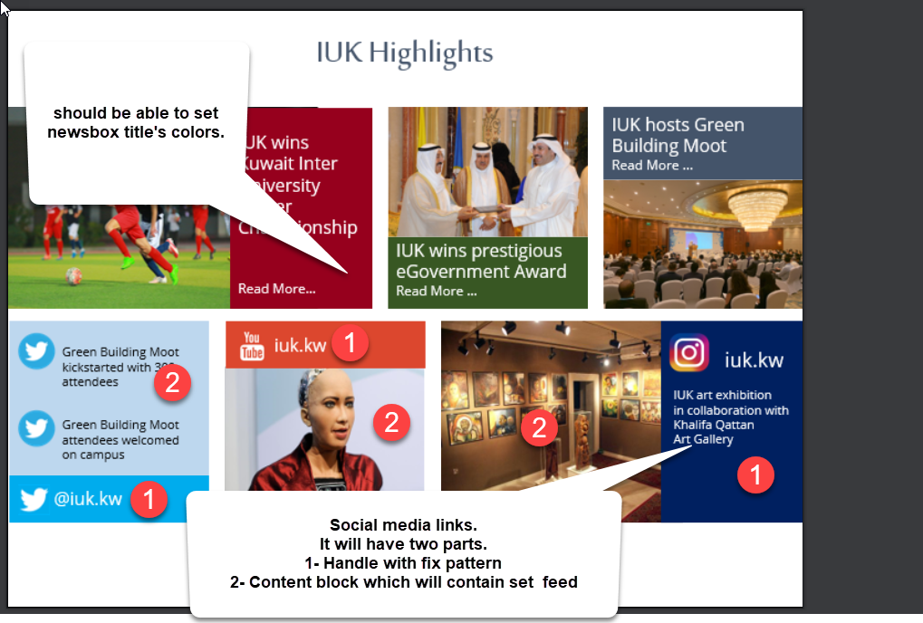

1. Footer.

Include Map and Footer bands. Its already like this

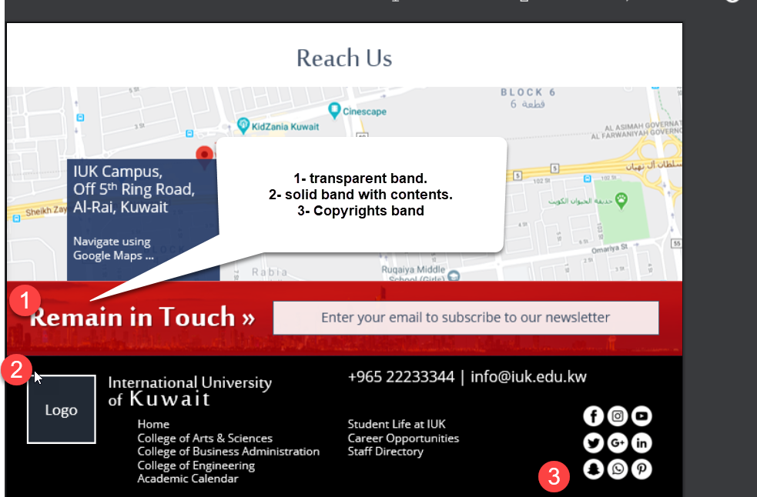

**Feedback:**

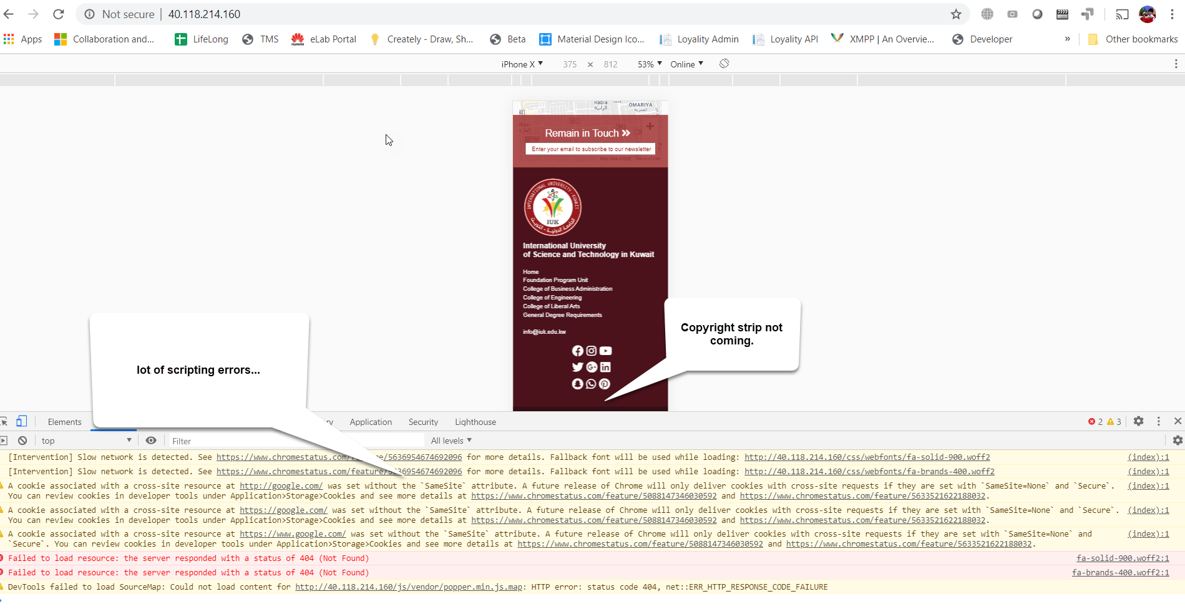

This will be fixed with backend by setting cookie headers.

**Layout Missing (Feedback)**

<https://www.iuk.edu.kw/generaldegreereqs>

* <http://40.118.214.160/general-degree-reqs>.html

<https://www.iuk.edu.kw/admissions>

* <http://40.118.214.160/admissions.html>
* <http://40.118.214.160/admissions-requirments.html>

<https://www.iuk.edu.kw/advisingcenter>

<https://www.iuk.edu.kw/pucscholarships>

**These pages are similar to below that’s why I didn’t estimated them. They are content pages which can be change with in future with backend**

**http://40.118.214.160/admissions-requirments.html**

**Required Document:**

**Please prepare a structure document/snapshots showing different image size requirement on different pages. Like banner image should be 1024 x 550 etc…**

**This can be extracted from same site if will if required then this will take some effort**